 COMMUNITY EDUCATION LEARNING CENTER

59 Thunderbird Dr. | P.O. Box 507

Dulce, New Mexico 87528

575-759-4339 - 575-419-0633

**Classroom Rental Agreement**

**Applicant’s Information**

**Name**__________________________________________________________________

**Address**___________________________________**City/State/Zip**____________________

**Mobile Phone**________________________**Email**___________________________________

**Date of Event:** _______/________/________to________/________/___________

**Time:** **START AT**____________AM/PM **END AT**_____________AM/PM (*Include Setup Time*)

(6:30 AM - 8:30 PM)

**Anticipated Number of Attendee(s):**____________ **Total Hours:**________________

**Description of Event:**_________________________________________________________

**Requests:** [ ] Tables___ [ ] Chairs___ [ ] Projector___ [ ] Whiteboard___

[ ] Copies___ [ ] Other(Specify)_________________________________________

**Layout of Tables/Chairs:**



[ ] [ ]

[ ] [ ] Draw your own

**RENTAL RULES AND AGREEMENTS**

_____ Applicant/Organization is responsible for the safety and conduct of their guests

_____ Use of alcohol, tobacco, open-flame, candles and or drugs is strictly prohibited

_____ Firearms or other dangerous weapons are prohibited on J.A.D.E CELC grounds

_____ Applicant/Organization is responsible for any damage to the classroom. All

damages must be reported immediately to CELC staff

_____ Applicant/Organization agree to not use other classroom work areas, staff equipment,

or other areas of the classroom. Use is limited to the classroom and bathroom. You must ask a CELC employee for use of item(s)

_____ Applicant/Organization must clean up after usage of classroom

_____ Applicant/Organization must ensure the bathroom stays clean while using

classroom

_____ It is understood, CELC is in no way responsible for any personal injuries, property

damage, or other liabilities that may be incurred during use of the classroom. Renter

agrees to release indemnity and hold the J.A.D.E Community Education Learning

Center harmless of any such damages. Renter must cover all repairs if damaged

_____ Applicant/Organization understand that nothing shall be attached to the walls,

ceilings, or any of the fixtures without asking a CELC employee first

_____ Parking will be available on the North side of the J.A.D.E building, on the westside parking lot of

the Community Center

_____ The Applicant/Organization shall assume all responsibility for all actions of their guest

and shall allow no unlawful or disruptive activities. The event shall be supervised

during the entire period of use

_____ Any copies needing to be made must be done by CELC staff. They can be reached in the

office

_____ All cancellations must be in writing or email and a minimum of 48 hours notice required

to cancel the reservation

_____ Violations of any of the classroom use regulations may result in the loss of the classroom

use in the future

_____ Applicant/Organization must understand the AC/Heater controls are controlled by CELC

Staff. If adjustments are needed please ask CELC staff

_____ Personal Events are allowed to be used in the Classroom, we do not offer food or drink services

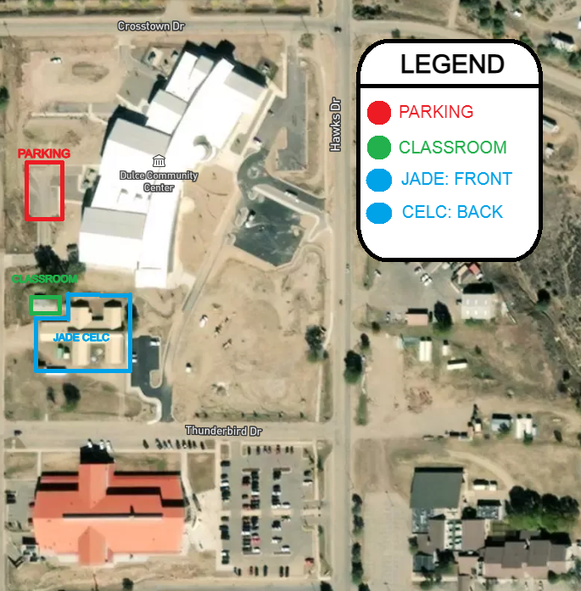

*By signing below you are confirming you have read and understood the Rental Rules and Agreements*

**Applicants Name (Print):**_________________________________

**APPLICANTS SIGNATURE:**______________________________ **DATE:**____________